(30 points)

Consider the following B-tree with t=3.Show all your work for each part.

8, 12, 15, 20

1,3,4,5,6 10,11 13,14 16,17 24,25,26,27,28

a) Insert 2 (10 points)

b) Insert 7(After inserting 2) (10 points)

c) Insert 30(After inserting 2 and 7) (10 points)

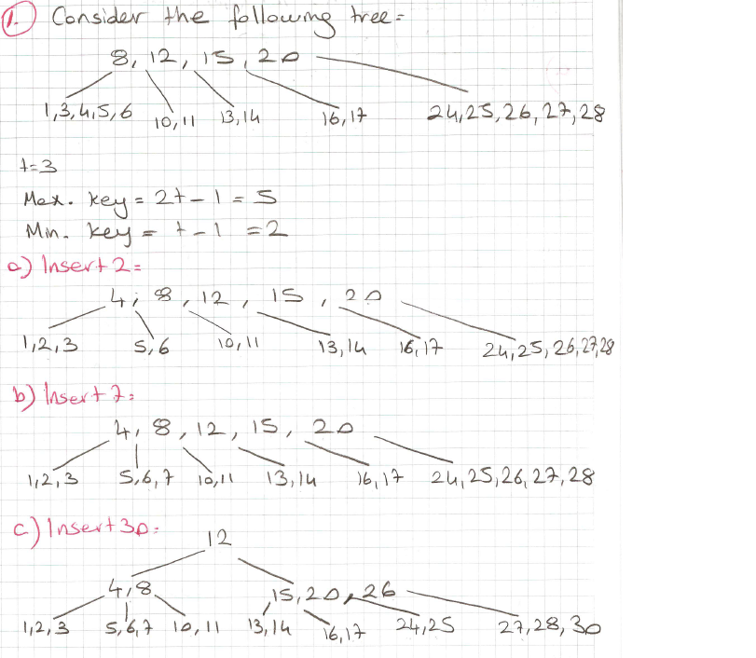
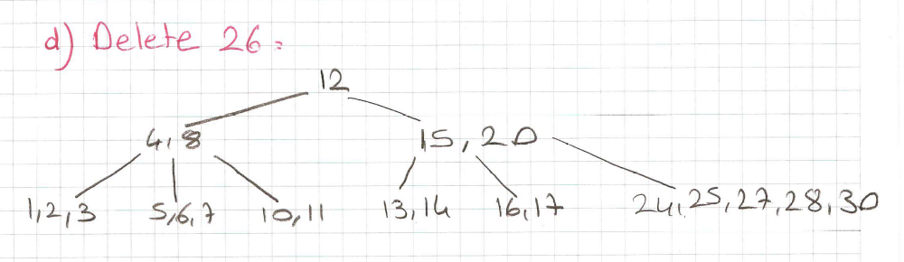

Q2.) (5+5+5+5 = 20 pts)

Consider the following B-tree with t=3. Show all your work for each part!

9, 23, 36, 50

1,3,4,5,6 10,11,14,15 24,25 37,38,39,40,41 54,55

Insert 2

Insert 42

Delete 39

Delete 9
Since t=3, Maximum key = 2t-1=5
Minimum key = t-1=2
a)

4, 9, 23, 36, 50

1,2,3, 5,6 10,11,14,15 24,25 37,38,39,40,41 54,55

b) 23

4, 9 36, 39, 50

1,2, 3 5,6 10,11,14,15 24,25 37,38 40, 41,42 54, 55

c) 23

4, 9 36, 50

1,2, 3 5,6 10,11,14,15 24,25 37,38,40, 41,42 54, 55

d) 23

4, 10 36, 50

1,2, 3 5,6 11,14,15 24,25 37,38,40, 41,42 54, 55

Q8. 2008-Midterm (10pts)
Place relevant letters in the nodes of the following ternary tree such that an LMNR (i.e., left-middle-node-right) traversal on the tree will result in “N₁A₁ZIM₁ HİKM₂ET RA₂N₂” to be displayed.

LMNR “N₁A₁ZIM₁ HİKM₂ET RA₂N₂”
R
A₁
E
N₂
N₁
I
Z
H
T
A₂
M₁
M₂
İ
K

Q10. 2007-Midterm (20 pts) (HOME EXERCISE)
The following recursive algorithm traverses a ternary tree (i.e., a tree of nodes with at most three children) in a specific way that I call “post-mid-order-traversal.” In the algorithm, print_key prints the key (e.g., the letter) of the node pointed to by p.

Place the letters in the string “M₁UST₁A₁FA₂ K₁EM₂A₃L A₄T₂A₅T₃ÜRK₂” into the nodes of the ternary tree below such that when the tree is traversed by executing the post-mid-order algorithm the string is printed. Disregard the space between the words!

Hint: The subscripts to replicated letters are given to specify their place in the string! While placing letters in the nodes, use these subscripts, too! Otherwise I do not accept your answer.
A₅
T₁
T₃
U
K₂
Ü
R
E
F
T₂
A₁
K₁
L
A₂
A₃
A₄
S
M₁
M₂
nodetype *post_mid (nodetype *p)
{
if (p != NULL) {
post_mid(p->left);
post_mid(p->middle);
print_key(p);
post_mid(p->right);
}
}

PS- STUDY:

4.) (30 points)

Construct a BST from the letters ”MACHINE LEARNING” where no duplicate letters are allowed.

Splay the node ”L”. (Show all your work with)

Q5. (15 pts) The following recursive function my_traverse traverses a quaternary tree (i.e., a tree of nodes with at most four children) in a specific way that we call “PMRLN-traversal.” In the function, print_key prints the key (e.g., the letter) of the node pointed to by p. The record for the nodes of the tree includes the fields, L for the first child, M for the second child, P for the third child, and R for the fourth child. place the corresponding numbers into the nodes of the quaternary tree below such that when the tree is traversed by executing the my_traverse algorithm, the following sequence is printed.

“BA₁ĞI₁M₁SI₂ZLI₃K₁ K₂A₂R₁A₃K₃TER₂İ₁M₂Dİ₂R₃”

nodetype *my_traverse (nodetype *p)
{
if (p != NULL) {
my_traverse (p->P);
my_traverse (p->M);
my_traverse (p->R);
my_traverse (p->L);
print_key(p);
}
}

R₃
İ₂
A₁
A₃
M₂
K₃
İ₁
R₂
K₂
E
T
R₁
D
A₂
K₁
B₁
L
Z
I₂
I₃
I₁
G
S
M₁

